Mockito Exercises OUTPUT

Name : Ganta Sri Ratna Hemanth

Superset id : 6124988

1. Mocking and Stubbing

**Step – 1 :** Create a maven project and add Mockito dependency in pom.xml file

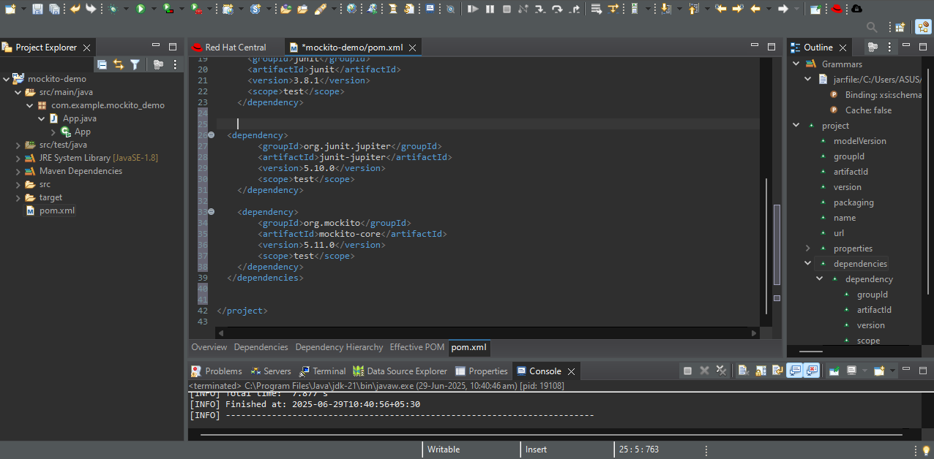

**Step – 2 :** Create 2 classes in src/main/java and 1 class in src/test/java

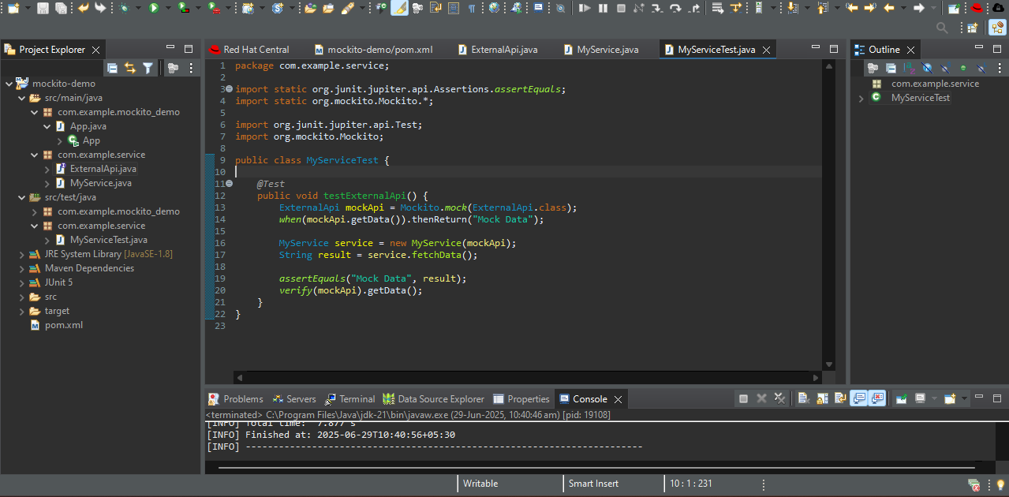

**Step – 3 :** Write the code in all the 3 classes and run it as junit test

ExampleApi code :

package com.example.service;

public interface ExternalApi {

String getData();

}

MyService code :

package com.example.service;

public class MyService {

private final ExternalApi api;

public MyService(ExternalApi api) {

this.api = api;

}

public String fetchData() {

return api.getData();

}

}

MyServiceTest code :

package com.example.service;

import static org.junit.jupiter.api.Assertions.*assertEquals*;

import static org.mockito.Mockito.*;

import org.junit.jupiter.api.Test;

import org.mockito.Mockito;

public class MyServiceTest {

*@Test*

public void testExternalApi() {

ExternalApi mockApi = Mockito.*mock*(ExternalApi.class);

*when*(mockApi.getData()).thenReturn("Mock Data");

MyService service = new MyService(mockApi);

String result = service.fetchData();

*assertEquals*("Mock Data", result);

*verify*(mockApi).getData();

}

}

OUTPUT :

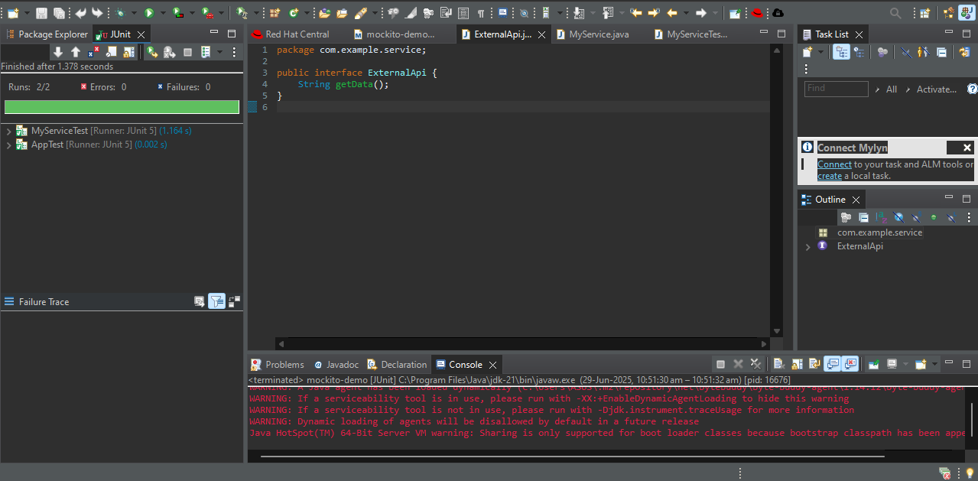

1. Verifying Interactions

**Step – 1 :** Create a maven project and add Mockito dependency in pom.xml file

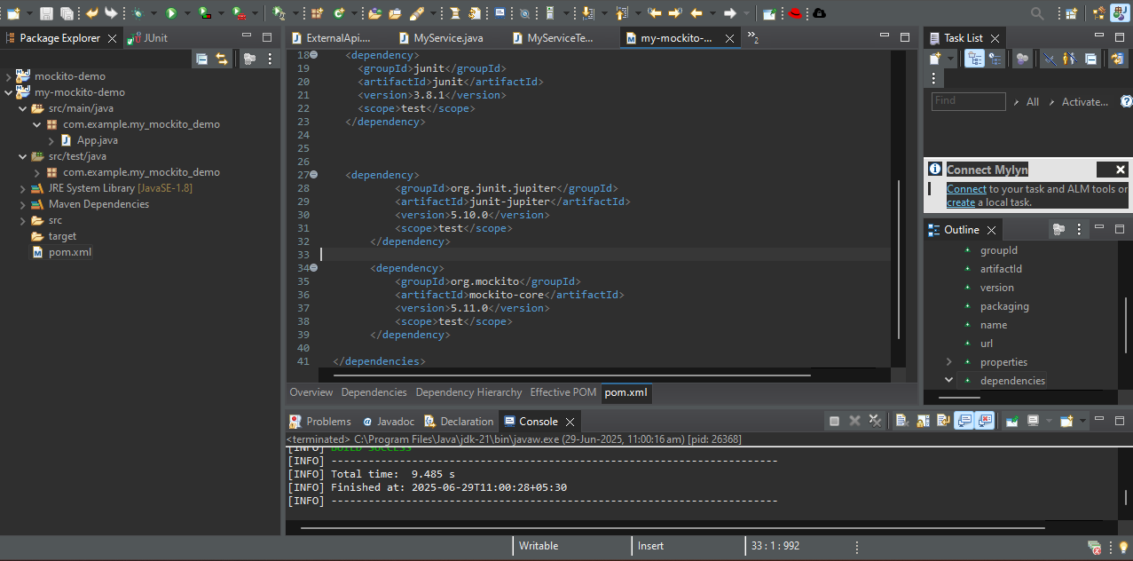

**Step – 2 :** Create 2 classes in src/main/java and 1 class in src/test/java

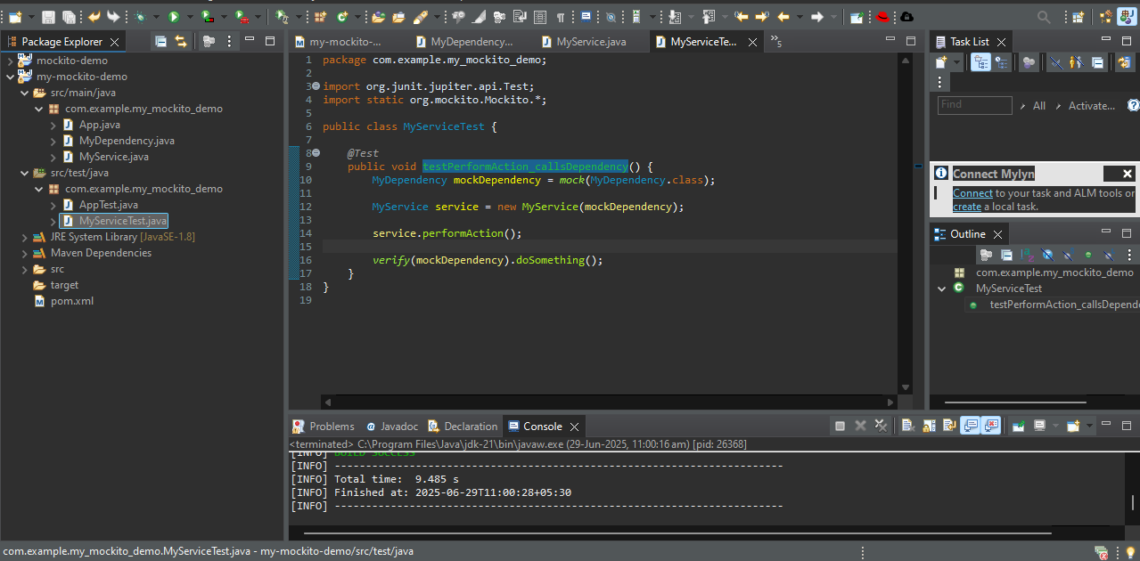

**Step – 3 :** Write the code in all the 3 classes and run it as junit test

MyDependency code :

package com.example.my_mockito_demo;

public class MyDependency {

public void doSomething() {

System.***out***.println("Real implementation.");

}

}

MyService code :

package com.example.my_mockito_demo;

public class MyService {

private MyDependency dependency;

public MyService(MyDependency dependency) {

this.dependency = dependency;

}

public void performAction() {

dependency.doSomething();

}

}

MyServiceTest code :

package com.example.my_mockito_demo;

import org.junit.jupiter.api.Test;

import static org.mockito.Mockito.*;

public class MyServiceTest {

*@Test*

public void testPerformAction_callsDependency() {

MyDependency mockDependency = *mock*(MyDependency.class);

MyService service = new MyService(mockDependency);

service.performAction();

*verify*(mockDependency).doSomething();

}

}

OUTPUT :

Run it as Junit test :

